|  |  |
| --- | --- |
| **US** *1.As a truck driver I should be able to  access Vehicle under Fleet module.* | **AC** *1.Verify that truck driver should be able to see all Vehicle information once navigate to Vehicle page.  2.Verify that when user click on any car on the grid, system should display general information  about the car  3.Verify that truck driver can add Event and it should display under Activity tab and General  information page as well . 4.Verify that Truck driver can reset the setting* |

AC-1. Verify that truck driver should be able to see all Vehicle information once navigate to Vehicle page.

#1 AC-1(Gherkin language)

Given I am on Vytrack login page  
And I am a Truck Driver  
When i enter correct login and password  
Then i should see truck driver's logged in page  
When i navigate to Fleet module  
And click "Vehicles"  
Then i should be able to see all Vehicles information

#2 Test Scenario

Truck Driver can see all Vehicles information under Vehicle page

#3 Test case

Go to Vytrack login page  
Enter correct username and password for Truck Driver  
Truck Driver Dashboard should be displayed  
Navigate to Fleet Module  
And click to Vehicles   
You should see all Vehicles information

Go to Vytrack login page

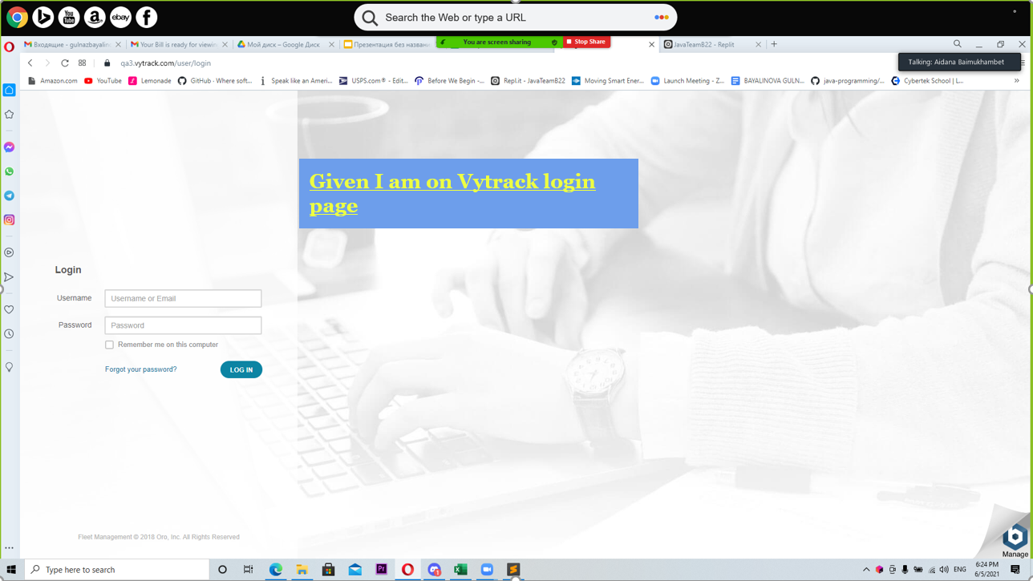  
Enter correct username and password for Truck Driver

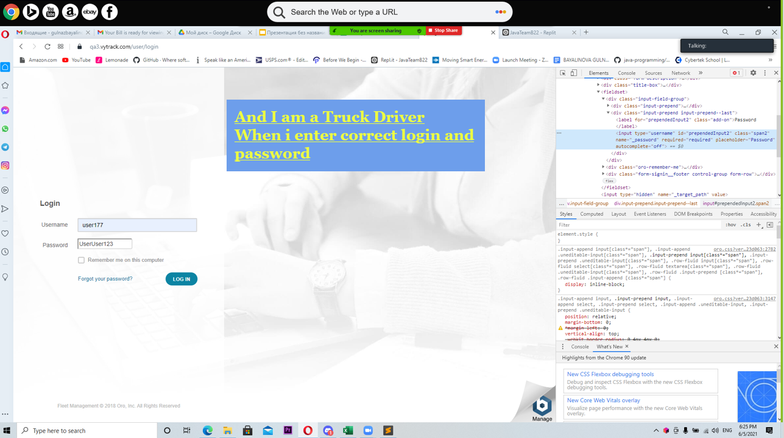

Truck Driver Dashboard should be displayed

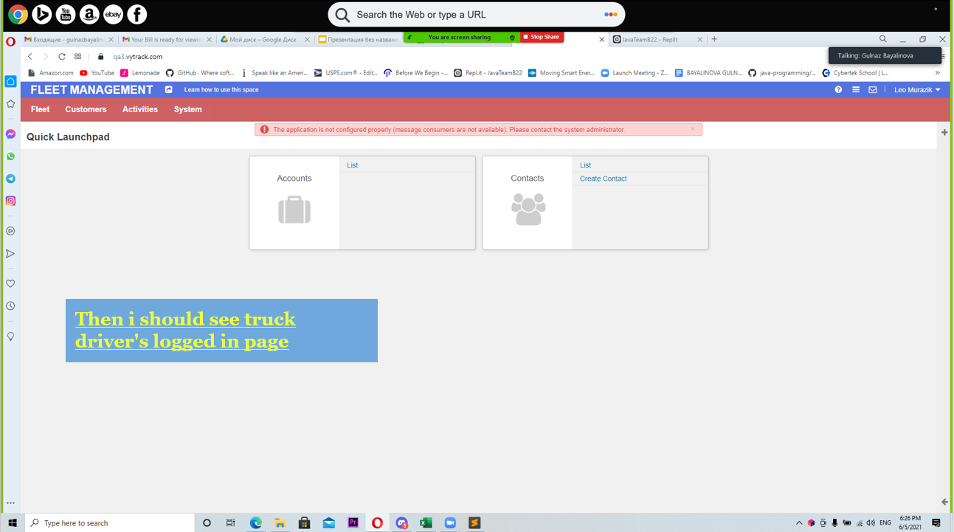  
Navigate to Fleet Module

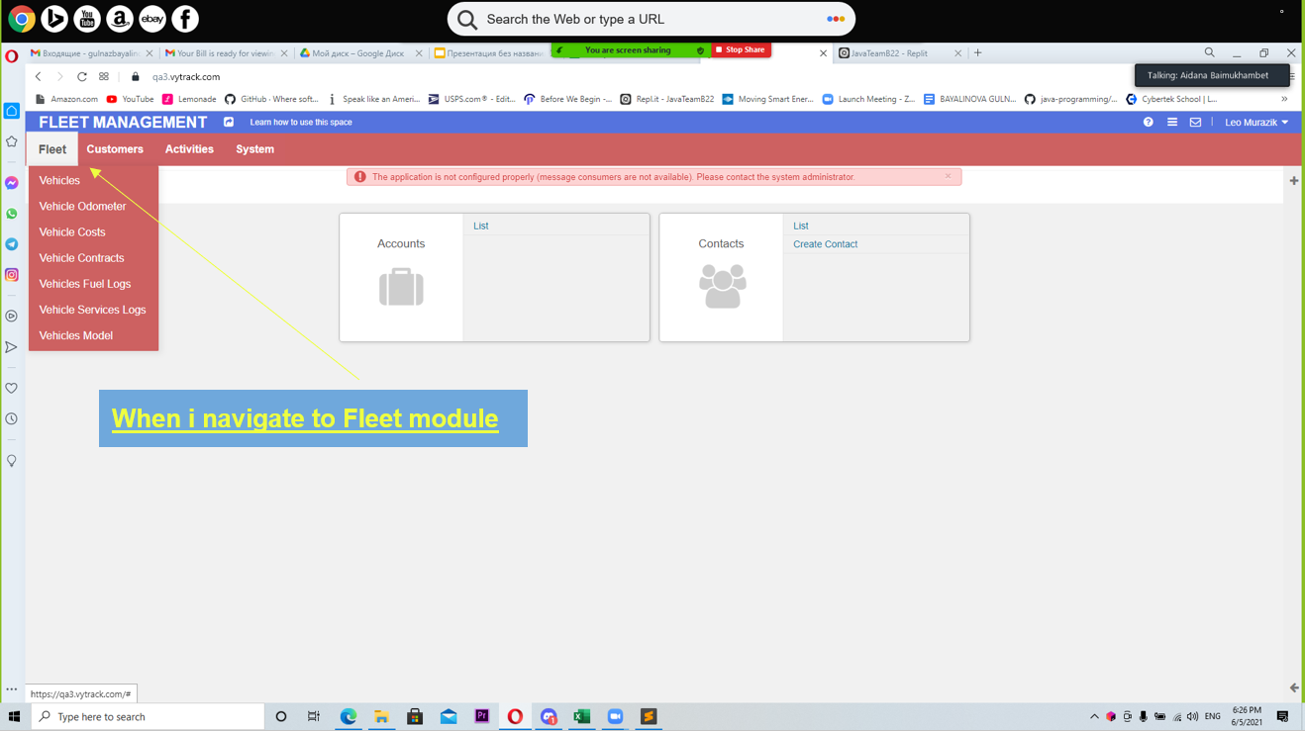

And click to Vehicles

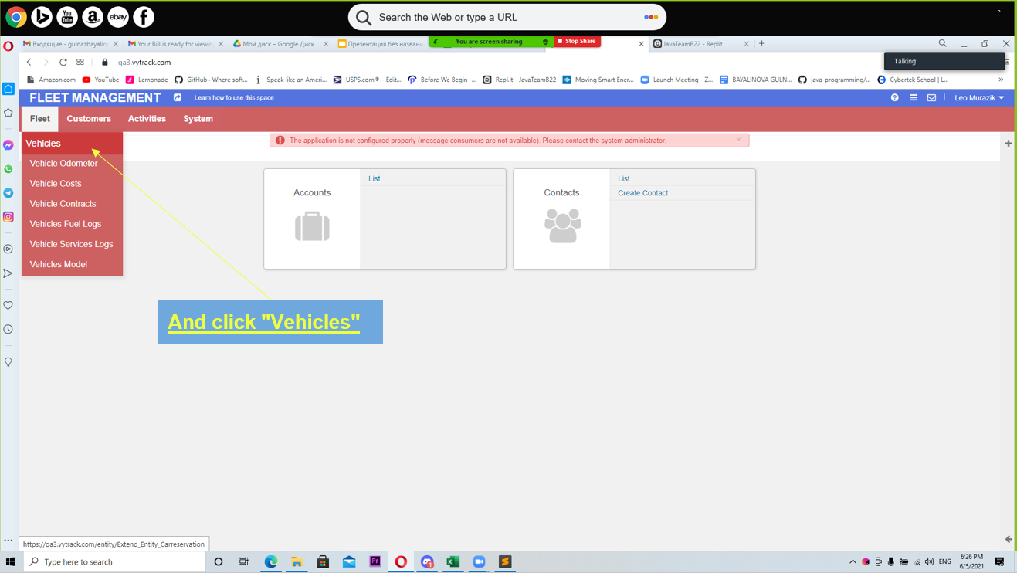

You should see all Vehicles information

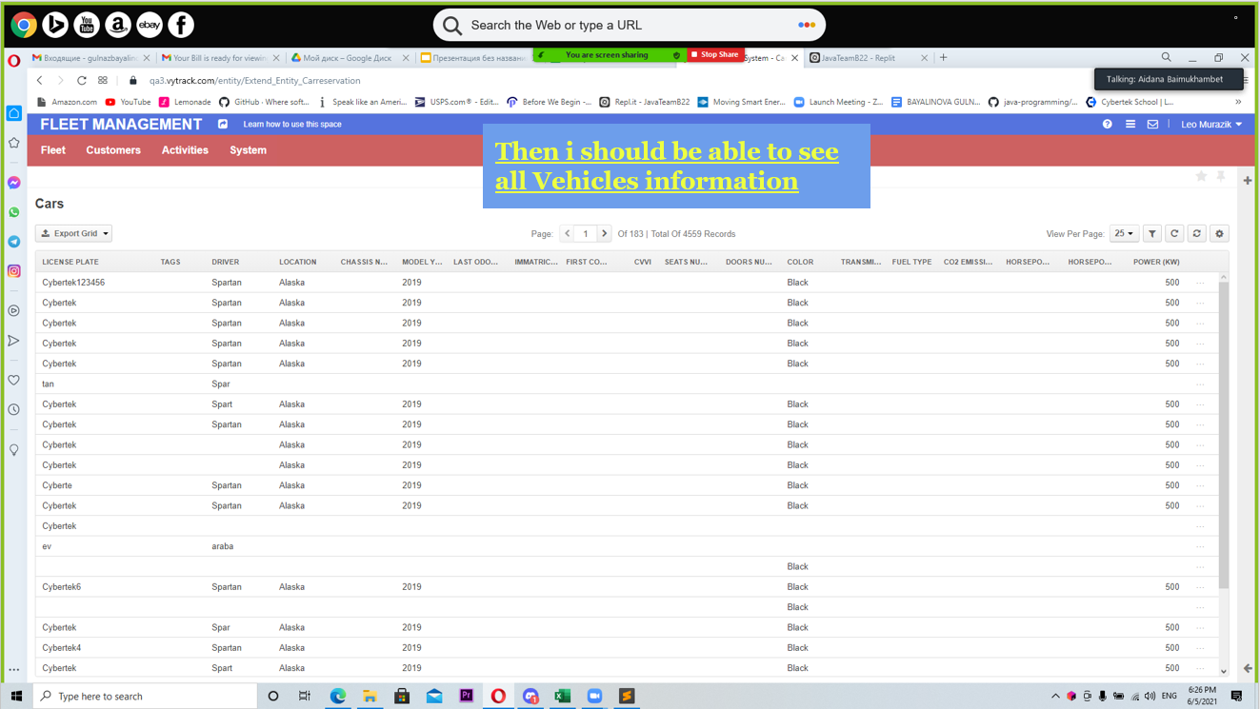

AC - 2. Verify that when user click on any car on the grid, system should display general information.

#1 Gherkin AC – 2

Given that I’m login into Vytrack application using truck driver credentials  
When I access the Vehicles under the fleet module  
And I click on any of the cars listed  
Then I should be able to see the general information about that car

#2 Test Scenario

* Truck driver should be able to see all the general information about any car when clicking on it.

#3 Test case

Go to Vytrack login page  
Enter correct credentials for Truck Driver user  
Truck Driver Dashboard should be displayed  
Navigate to Fleet Module  
And click on the Vehicles page under Fleet Module  
You should see all Vehicles information  
Click on one of the cars  
All general information about the car should be displayed.

Go to Vytrack login page

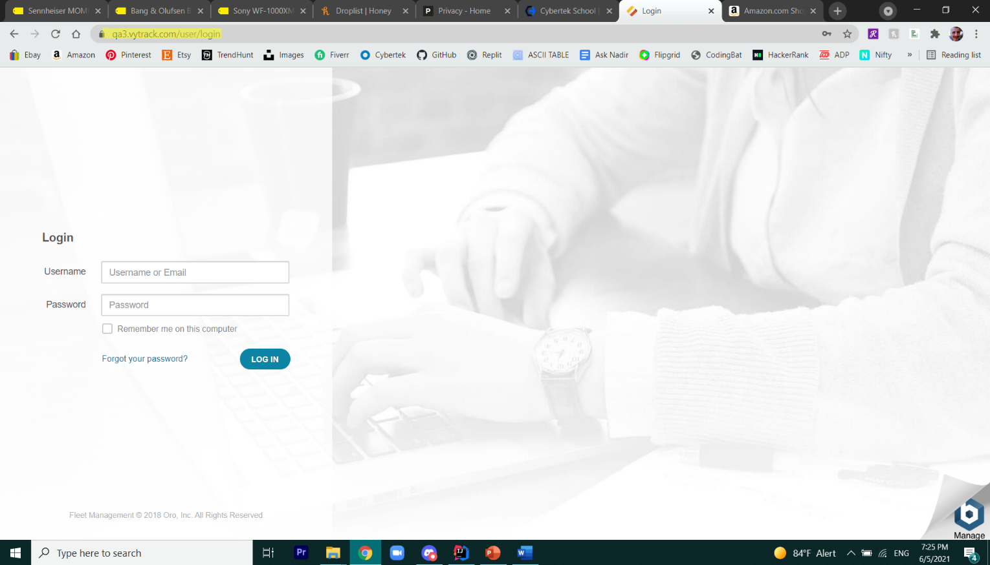

Enter correct credentials for Truck Driver user

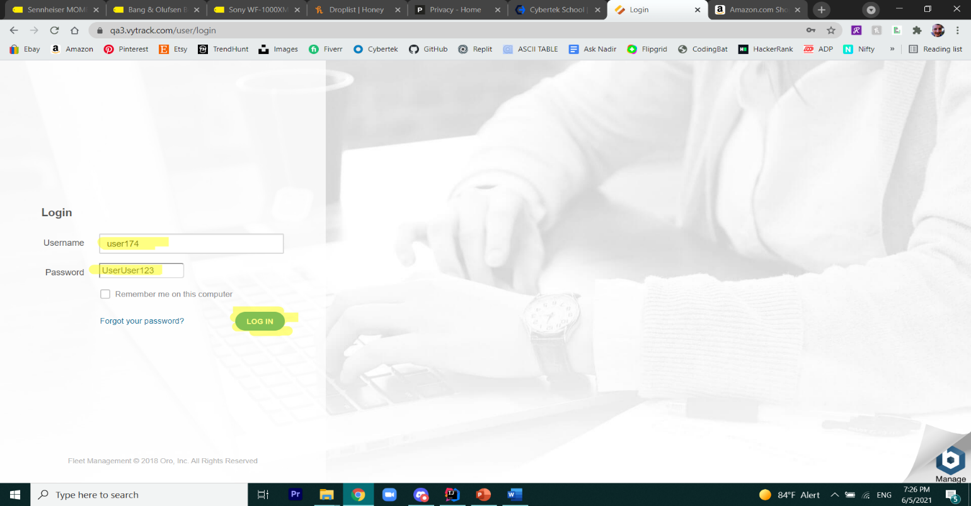

Truck Driver Dashboard should be displayed

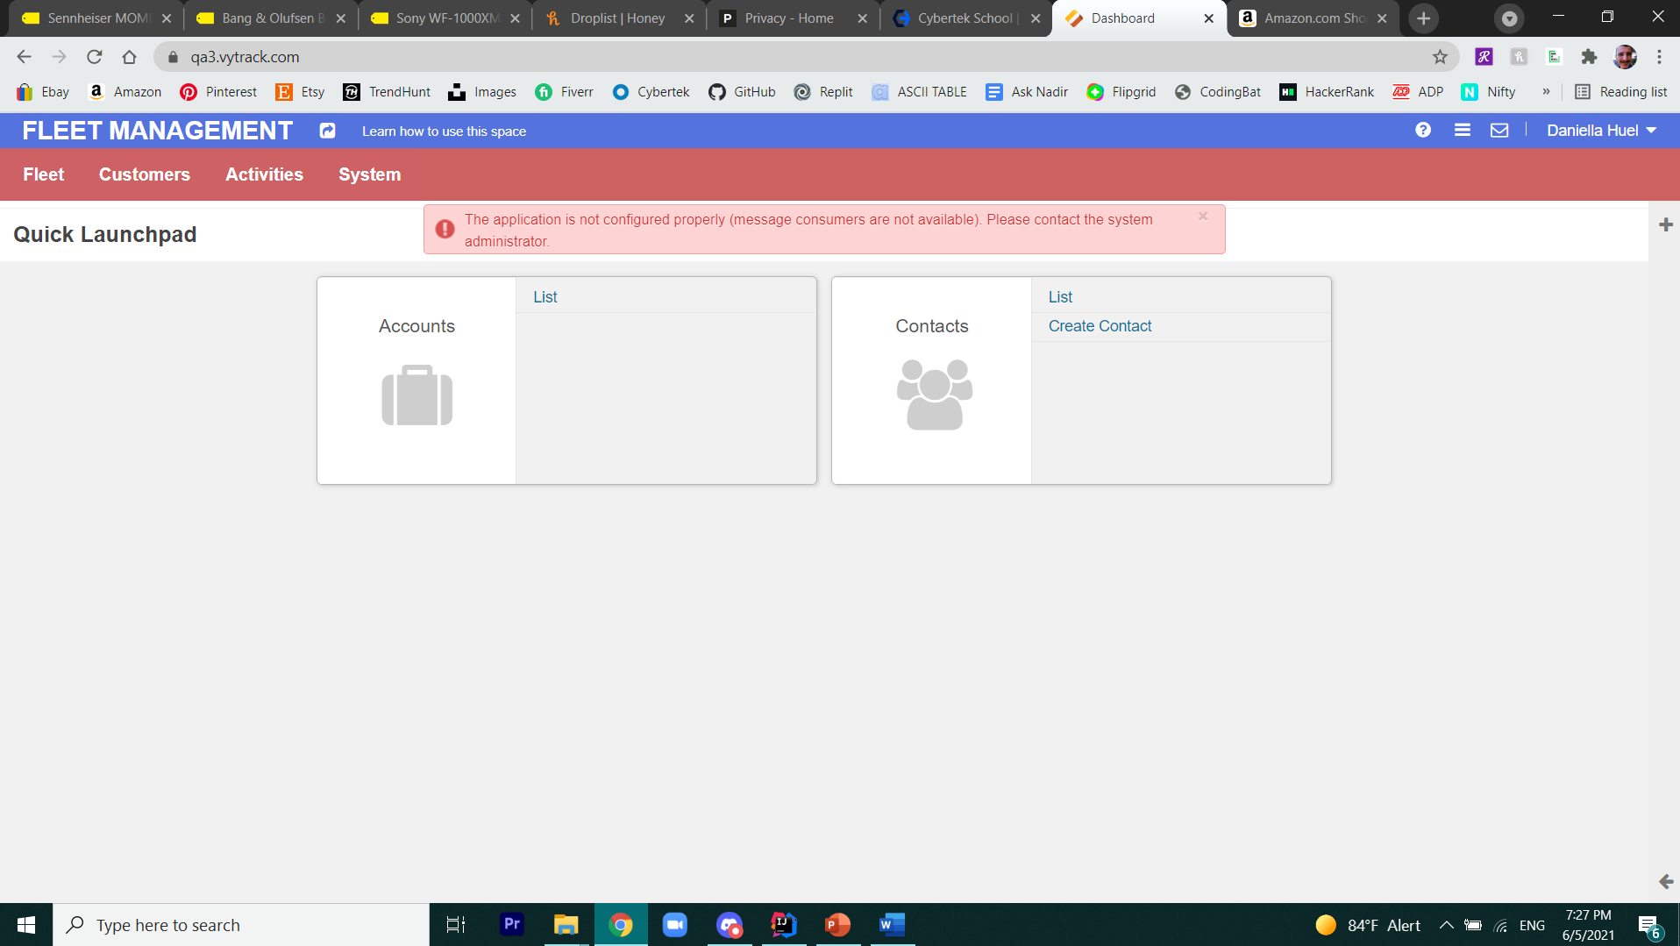

Navigate to Fleet Module

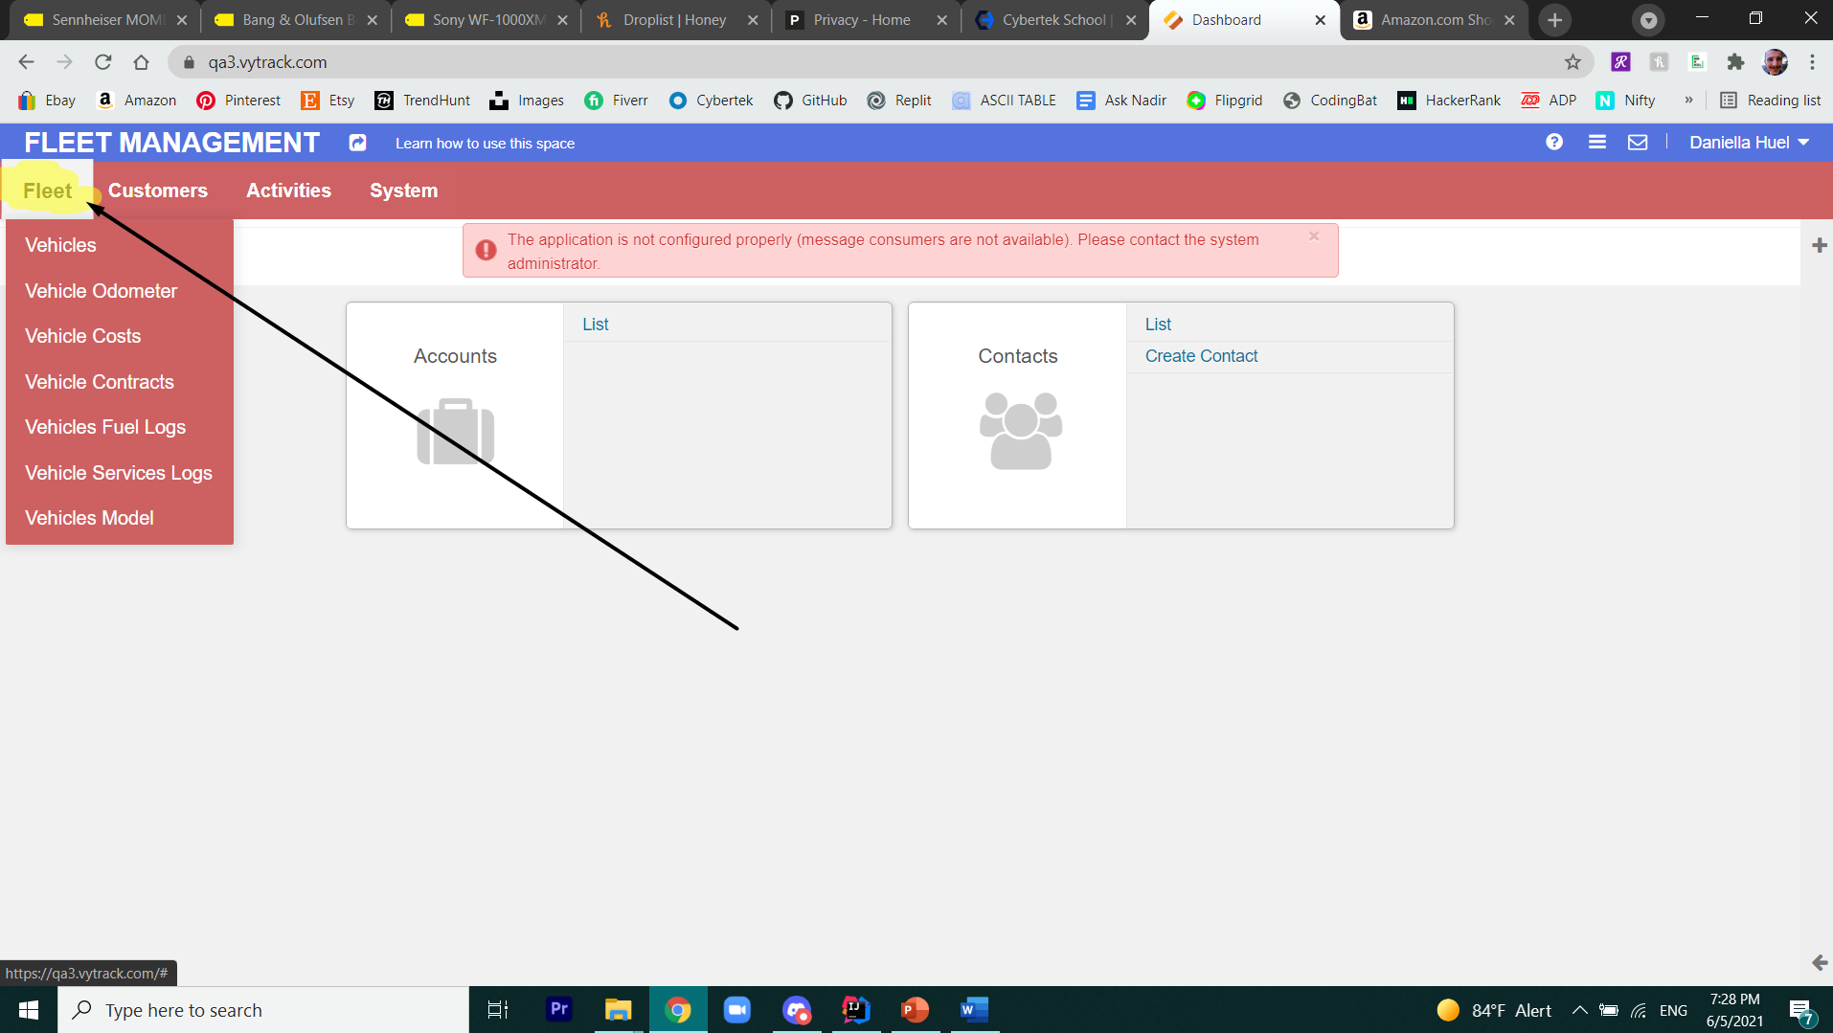

And click on the Vehicles page under Fleet Module

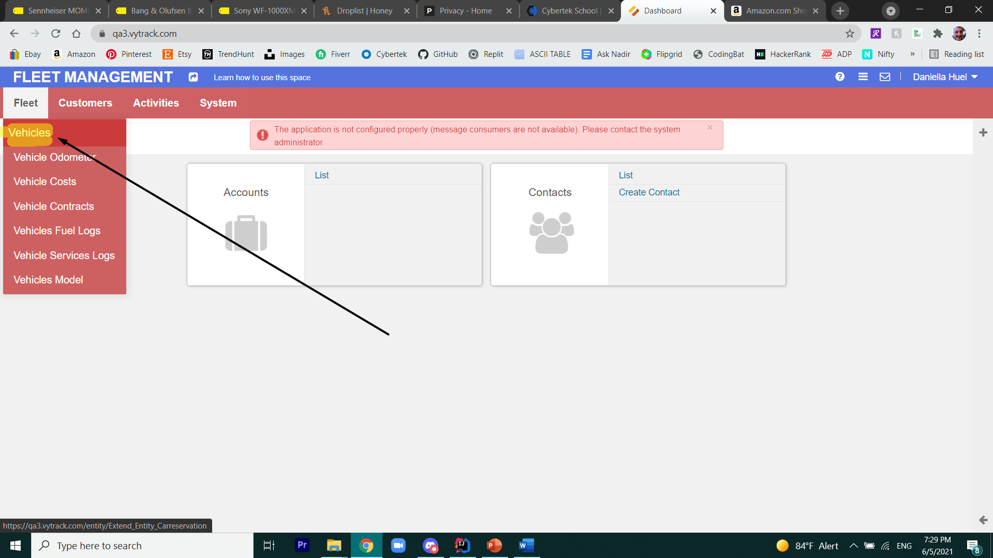

You should see all Vehicles information

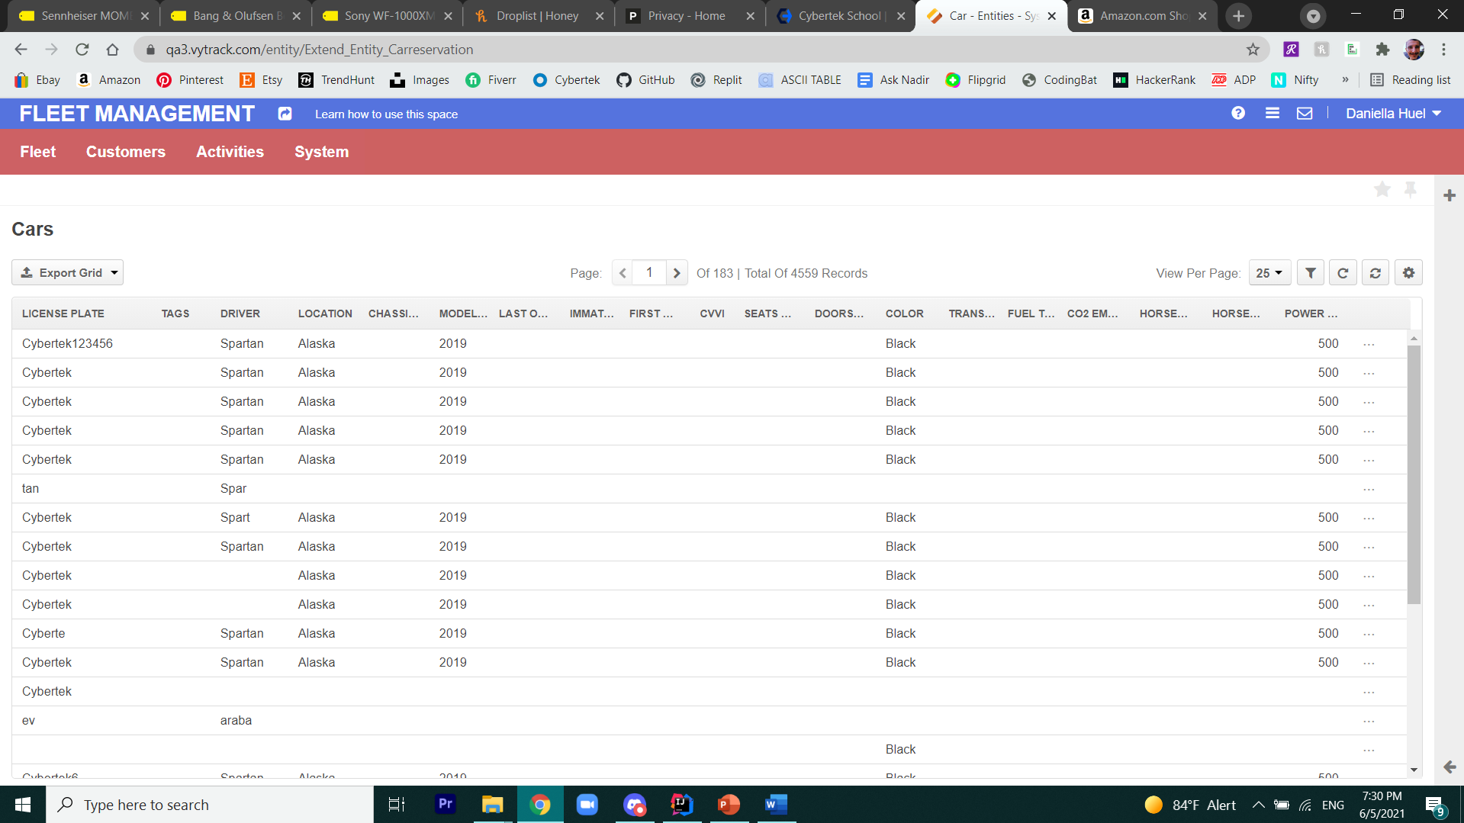

Click on one of the cars

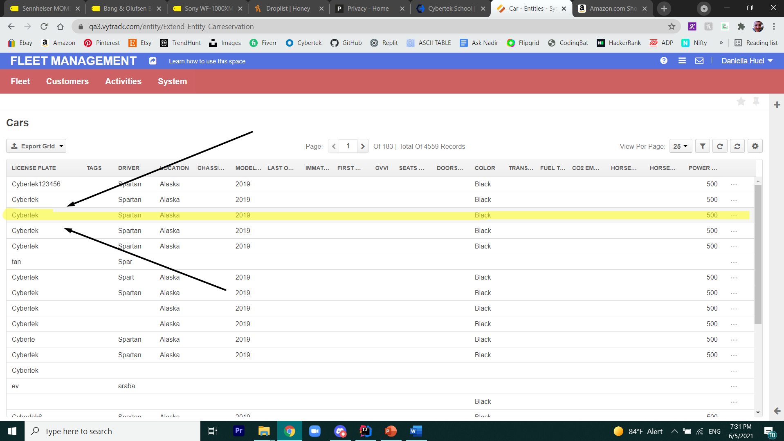

All general information about the car should be displayed.

